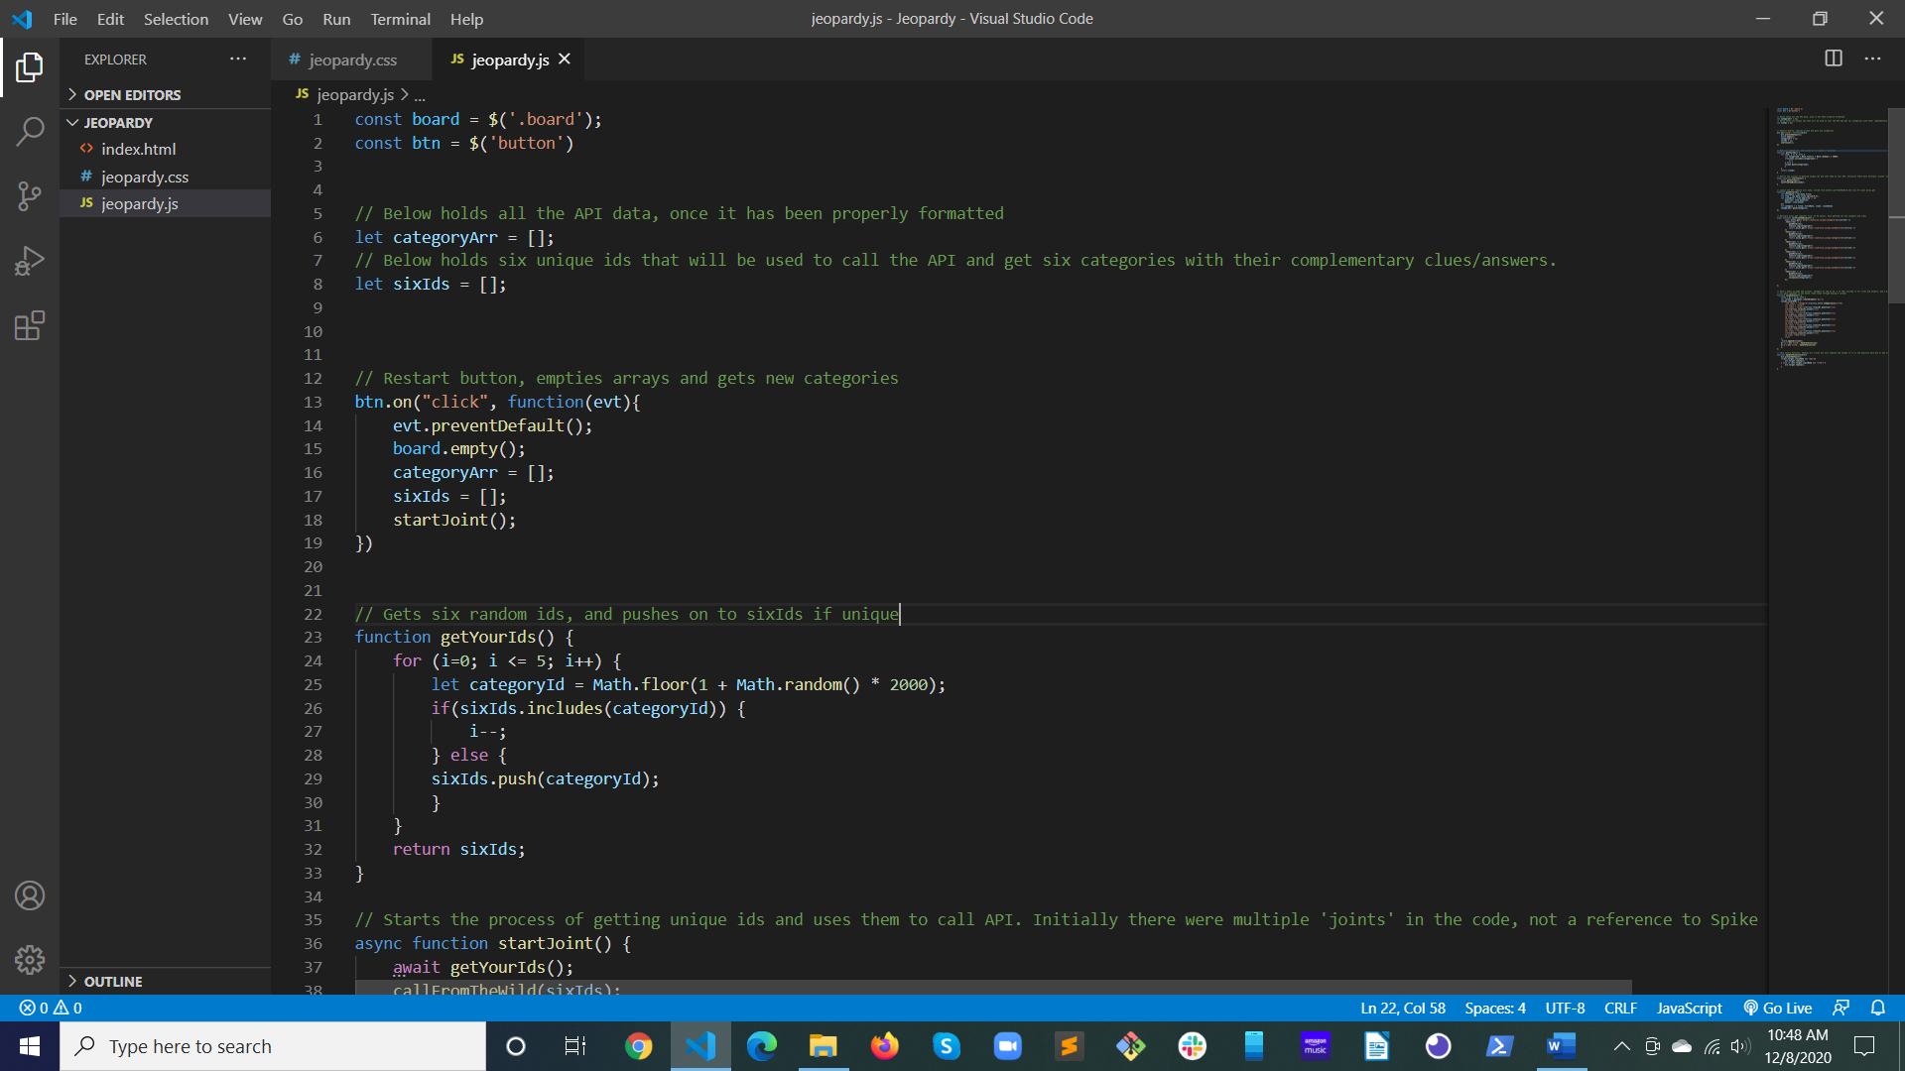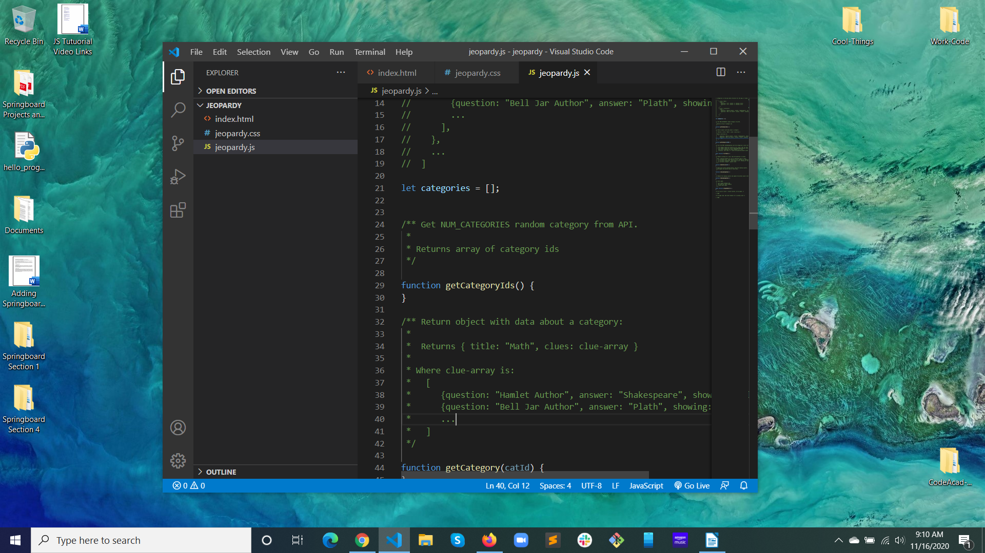Start: 9:10 AM 11/16/2020

FINISH: 10:48 AM 12/8/2020